UJUMBE APPLICATION DEVELOPMENT REPORT

KARIUKI MARTIN MIANO

SCT211-0668/2016  
BSC. IN COMPUTER SCIENCE

JAVAN OYUGI

SCT211-0278/2015  
BSC. IN COMPUTER SCIENCE

LUMBASI JERRY SHIKANGA

SCT211-0084/2016  
BSC. IN COMPUTER SCIENCE

BRODERICK ALIWA

SCT211-0093/2016  
BSC. IN COMPUTER SCIENCE

KINYUA DAVID

SCT211-0527/2016  
BSC. IN COMPUTER SCIENCE

# INTRODUCTION.

## Background:

Most small-scale farms in Africa are rain-fed, meaning the farmers have little or no access to irrigation, and the water available for crop growth is determined by natural rainfall patterns; This means that these farmers’ yields are highly dependent on local weather conditions. They often complain that their traditional ways of managing their farms no longer work because rainfall patterns of the past have been disrupted or changed; Whereas sowing could previously start in early June, farmers now find their seeds germinating poorly due to delayed rains.Whether the cause of these delays is deforestation,climate change or natural climate variability is of no importance to the farmer and the fact is that the resultant waste of energy and inputs could be avoided, particularly if farmers had more information about local weather and forecasts. Smallholder farmers are far more practically interested in data. For example, they ask very practical questions. What crops I should grow? How do I grow these crops? Which inputs do I use and where can I get them? Where do I store my harvest? Where do I sell my crops and at what price?

Reliable weather forecasting is key to improving their farm management; Studies of farmers’ experiences of weather variability indicate that farmers attribute decreased crop yields mainly to changes in weather patterns. For rain-fed agriculture, it is crucial for farmers to know when the rainy season will start. The questions to which farmers need answers include: whether sufficient rain is forecasted for them to start sowing, and whether the first shower will be followed by another period of drought. Although farmers trust the historical patterns for the start of the rainy season, the onset of this season is not as clear as it used to be.

## Problem Statement:

There is overall a low utilisation of farm data by small-scale farmers partly due to the fact that, data are not synthesised into simplified formats and languages that are user friendly to farmers and local communities. The current manner in which farm data are presented is more applicable in management and decision making at the policy formulation level and programme development. There are also a few existing providers providing the data. However, most of these provide it in ways the farmers can't access. These include smartphone-only applications. Most small-scale farmers don’t have access to the smart phones or those who have only a few of them know how to use them. Most farmers receive their weather information and forecasts via television or radio. These services are often provided by the national weather services and via local radio broadcasts. However, the disadvantages of this method is that it is difficult to make the forecasts location-specific or tailored towards user needs.

## Approach

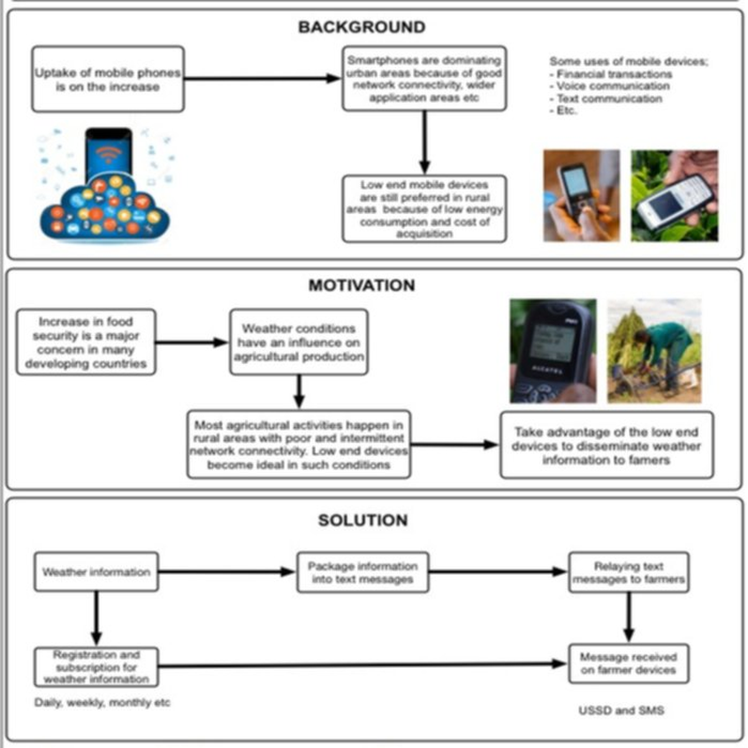The team’s approach in development of the following project utilized agile development processes in particular scrum apprroach where by there were three key phases: Initial phase where we established the general objectives for the project and design the software architecture, followed by a series of sprint cycles where each cycle develops an increment of the system and project closure phase which wraps up the project, completes required documentation. To ensure we were on track we also designated a scrum master among the team members to protect the development team from external distractions.At the end of the sprint, the work done is reviewed.

# DESIGN DESCRIPTION.

## Design concept:

Components: 1. Weather: This has several modules, majorly Models which will define the database structure. The major models are Country, Location, Location Weather which is of two types either current weather or Forecast weather Tasks. These are majorly functions. They will be called periodically by celery and sent to a worker to process them. They retire data from Open Weather ApI and save it to the Database.

2. Africa stalking: This holds several modules Urls which map requests to views; Views which process the callback request from Africastalking. 3. Models: to define how data will persist in the db. These include USSD session, incoming and Outgoing messages. 4. Profiles: Models which define how user data will be stored in the db. They include Profile which will hold user bio details, location, phone number and account balance.

Others are subscriptions and a record of charges on accounts for accounting purposes. Signals pick up changes from external apps and process them.

Connections: Each of these apps has a tests module. This performs the test on each individual module. The scripts directory is used when setting up or cleaning up the db. The requirements.txt specifies the packages needed by the system to run. Settings directory defines the system setting in different environments.

## Technology used in the prototype

External data shall be obtained from external api’s and data. The system is built using a MySQL database. This is used for storage of all the data. Google cloud SQL serves as the MySql Client. Python is used as the server programming language. This is because its highly suited for two major components of the system i.e. web applications and data analysis. Therefore the system language shall be consistent. Django web framework is used to handle the web application modules. Scipy, numpy, pandas, statsmodels and sci-kit learn are used for data analysis. Nginx is used as the web server. The application is asynchronous, that means the users place a request which is then added to a queue and the results returned later. This is to prevent a situation where a user waits for long to have results. Queue management is done by celery with rabbitmq as the broker. All these components are combined to form a REST API. This will provide data to the SMS, USSD, web and mobile clients. Server side work is underway already. On the client side, we shall have multiple clients. There will be a web client.This shall be built using HTML, CSS and Javascript. It will use a Javascript framework, either ReactJS or AngularJS. USSD and SMS Logic will availed too. There will be two mobile clients Android and iOS. The android will be developed first using kotlin then iOS using Swift. This is based in the fact that Androids are generally more preferred by small scale farmers. They are generally cheaper and more customisable. All these clients will use the API currently under development.

# TESTING.

Testing approach predominatly used is the functional testing, in particular: the unit test, module test and system integration test. As earlier mentioned, Each of these apps has a tests module. This performs the test on each individual module. The unit test aids in testing individual components, module test aids with testing the various modules and finally system integration aids aims to test how various modules integrate with each other. Also another keen test we look forward to conduct is the acceptance test, a test by end users. It is important we are able to get feedback from the end users, small scale farmers on the look and feel of the application. This is because the application should be tailored in such a way that encourages simplicity and effective communication.

## Setup

One of us sits in a separate environment with an eye tracking device. She shares her screen with a participant while they are video chatting. The participant sees where the other person is looking, which part of the face or somewhere else entirely, in order to improve the sense of eye contact and therefore the Skype experience. The participant simply has a nice conversation through Skype about their project, and as additional information the participant can see where exactly the other person is looking. To avoid bias we told them as little as possible before the test, and afterwards we discussed the concept and possible improvements.

To start off the user test the participants were asked about their previous experiences with video conversation: what do they use it for and what are difficulties?

The second part was a normal conversation through Skype using our platform with eye tracking. The participants were asked to tell about their projects, with which we hoped that participants would focus on the conversation rather than on the fact that they were in a user test.

After the user test participants were asked if they felt involved during their conversation and if they felt there was any difference from a regular Skype conversation. Besides this, the look and feel of the design were discussed and how they could be improved. Finally we asked the participants whether this, if it was better visualised, would add value for them.

# CONCLUSIONS.

## Look and feel of the platform:

Registration:

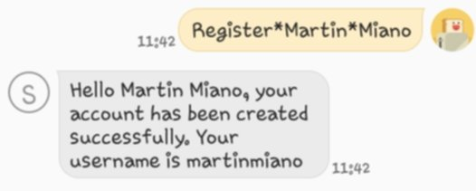

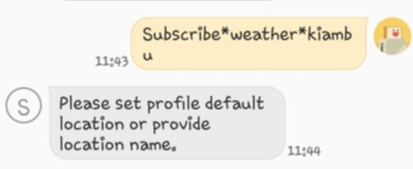Subscription:

Weather sms:

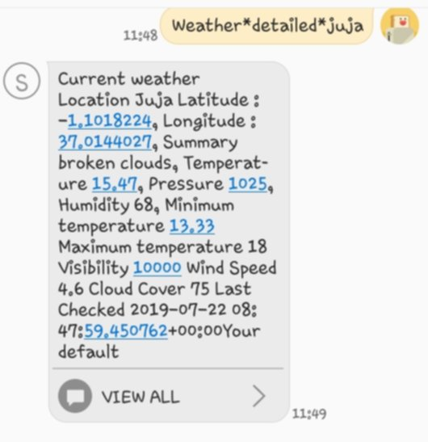

## Limitations:

For cases where the data may not be readily available, we have to make use of technicians to help collect the data. Inadequate logistical and technical support for them to facilitate accurate and timely data collection and monitoring field activities is a serious problem in terms of ensuring data quality. This is compounded by the long distances they have to cover to collect data, making data collection very costly and cumbersome and resulting in delays in data collection and analysis. Providing information in the local language is also important, but translating messages into indigenous languages can be challenging, particularly in countries where numerous national languages or dialects exist. In Ethiopia, for example, more than 80 different languages are spoken. Translating messages from English into indigenous languages may pose problems since the meaning of a word may differ from one region to another. Reliable translations need to be made by local experts who are familiar with the language or dialect, the farmers, the use of common symbols and the local weather jargons. Also a key issue to contend with is the accuracy of the translation in terms of the meaning. Certain sentences when translated from English may lose meaning if directly translated to the local languages, intelligence is needed to translating certain sentences accurately without them losing their meaning.

## Overall experience

It was very key for the designers to be able to ensure simplicity as simplicity is very key on effect the application has. This was achieved by ensuring the process of obtaining the data is direct as possible whilst containing very relatively few steps. We aim on be able to fully translate the messages whilst maintaining the message itself. Poor translations are bound to have the message either lose its meaning or be rendered unreadable.

## Future opportunities of the platform

Two major areas that the application can improve upon:

* Translation: translation is a key as it greatly affect communication. Proper translation ensures that there’s proper communication and users are able to understand the message.
* Decision Making Framework: A major aim in the future is to create a decision making framework that enbles the users(small-scale farmers) to make decisions that will optimize yields by knowing what crops are suitable to plant when and favourable markets for sale of their produce.

# DISCUSSION

African small-scale farmers are the target group as they have the highest potential to increase agricultural production and provide the continent with long-term food security. However, this data is not only limited to small scale farmers, it can also be used by the large scale farmers and co-operations. Other market players can also utilise the data provided by the system for decision support. Meanwhile, warehouses can better estimate storage and transportation capacity, while traders can more accurately estimate expected shortages or surpluses. The service can also be expanded to other continents and countries, for example India.

The goal of this project was to bridge that divide between small-scale farmers and the available data(in specific weather and market data). This project is to be a stepping stone as we look further to create a framework that will help farmers make decisions such that they can profit from favourable markets and optimize yields from the knowing what time is best to plant certain crops.